

Software Requirement Specification (SRS) For

Medicine Recommendation Application

*VERSION 1.0*

# Prepared by:

**20CS029-Nishant Kotadia 20CS033-Mohit Marvania 20CS034-Darsh Marvaniya**

# TABLE OF CONTENTS:

1. **Introduction**
   1. Introduction
   2. Document Conventions
   3. Project Scope
   4. Reference
2. **Overall description**
   1. Project perspective
   2. Product features
   3. User classes and characteristics
   4. Operating Environment
   5. Design and Implementation Constraints
   6. User Documentation
   7. Assumptions and dependencies
3. **System** **features**
   1. Descriptions and Priority
   2. Functional Requirements
   3. Module Descriptions
      * Type of user
      * Administrator module
      * Complaint
      * User module
      * Medicine search
4. **External Interface Requirements**
   1. User Interface
   2. Hardware Interface
   3. Software Interface
   4. Communication Interface
5. **Other Nonfunctional Requirements**
   1. Performance Requirements
   2. Safety Requirements
   3. Security Requirements
   4. Software Quality Attributes
6. **Introduction**

### Introduction

Around the world we need to aware about basic disease and which medicine is useful to stop that disease at basic level to high level. We are design an application for every people for medicine suggestion. The basic purpose of this application is to give a suggestion of medicine to patient. The application contains of list of medicine for all disease.

### Document Conventions

* + - Entire document should be justified.
    - Convention for Main title
      * Font face: Times New Roman
      * Font style: Bold
      * Font Size: 14
    - Convention for Sub title
      * Font face: Times New Roman
      * Font style: Bold
      * Font Size: 12
    - Convention for body
      * Font face: Times New Roman
      * Font Size: 12
    - Publish, cancel, edit and save Box
      * Font face: Time new roman
      * Font Size: 12
      * Font style: Bold
      * Block color: Red

### Project Scope

* Medicine Recommendation Application is basically for medicine suggestion for patient so that the user can know the details of medicine can he/she can take for their disease.
* The product will work as a complete user-friendly interface for medicine recommendation process and also doctor can use this application for enhance their knowledge about medicine.
* It is especially useful for any Medical Store where medical worker can easily give the medicine to patient of basic level and also useful for patient.
* The Medicine Recommendation Application can work as a powerful application for easy to use for user.

* The product provides the members account and it can easily show his/her profile in this application and see history about medicine.
  1. **References**
* Google Android Tutorials.
* Android Studio Tutorials (YouTube).

## Overall description

### Project perspective

The Medicine Recommendation application is used for recommending medicine for several common disease. The medicine application will have a feature to login so that the user can keep a record of the medicine used by them and can also save the medicine name in their profile. The user can search about the disease can the application will provide the information of medicine used to recover from that diseases, there will be list of medicine displayed to the user from which the user can choose one for them.

### Product features

* + - Admin
* Admin should be able to insert, modify and delete medicine detail.
* Add and edit Medicine and diseases.
* Identify the medicine from the diseases entered by the user.
  + Normal Users
* User can login with their credential.
* User can able to save their previous recommendation medicine.
* User can search disease.

### User Classes and Characteristics

The application provides information about medicine for various disease.

The features that are available to the admin: -

* Admin can add medicine.
* Admin can add disease.
* Admin can edit or modify the old entered medicine and disease.
* Admin can see patient review/recommendation.

The features that are available to the user: -

* Can view the different type of medicine for different disease.
* Can view their profile.
* User can update/modify their profile anytime.
* User can search any disease.
* User can search any medicine.
* User can able to save their previous recommended medicine.

### Operating Environment

The medicine recommendation application will be operated in android devices, as it will be built in android studio. The only requirement to use this application is to download the application. The application can be used in the offline mode also.

SOFTWARE CONFIGURATION: An android device which support Android 4.4 or greater.

### Design and Implementation Constraints

Any update regarding the medicine will be updated in the application as soon as possible. Application will provide about 90% correct information.

### User Documentation

The User documentation will include: -

* User will be able to see help button in our application.
* User can use save button in application.
* User can use online links for medicine detail (In the upcoming updates of the application).

### Assumptions:

Assumptions are: -

* The system should be user-friendly so that it is easy to use for the users
* The system should provide search facility
* The medicine recommendation system is running 24 hours a day

## Overall description

### Descriptions and Priority

1. First priority goes to the home page. when user will login the system there will be home screen which will assure to the use either ha wants to enter or exit.
2. User Login with their id and password.
3. Second priority goes to the menu form where the contents, manuals, and some others functions of the system. From the menu form the user can go any form of the Application.
4. In the menu form there will be a facility to select their choice for working like if the user just only wants to search the medicine, then he will only select the search field and go to the searching.
5. Similarly, if the user wants to see the profile of his/her then he/she can visit profile page.
6. The menu shows according to user and they can access all information.

### Functional Requirements

* In this Application there are lots of functioning for searching medicine.
* The Applicant can Search any medicine and see the detail about medicine.
* The user can also see their profile and edit.
* He will be able to get the records.

### Module Description

1. **Type of user**
   * Administrator
   * Doctors
   * Patient
   * Medical store people
   * Medical staff
2. **Administrator module**
   * Add/Edit Medicine Data
   * Create Profile
   * Change password
   * Book inventory
   * User information
   * Report generation
   * Search disease
   * Search Medicine
3. **Complaint**
   * All user can send their complaint
4. **User module**
   * Change password
   * Search disease
   * Search Medicine
   * See account information
5. **Medicine search**
   * Normal search by alphabet
   * Quick search by type (Book id, Author, Publication)

## External Interface Requirements

### User Interface

The application provides good graphical interface for the user to operate on the system, performing required task such as creating account, searching the diseases, etc.

* The application allows the user to create an account.
* It also allows to search for a particular diseases and will show the related medicine for that diseases.
* The user can save the name of the medicine from the list shown so that they can refer to it lately.
* In the future updates of the application the application will also provide the google link for the medicine so the user can also get more information about the medicine.
* Also, the user can login/logout from the application.

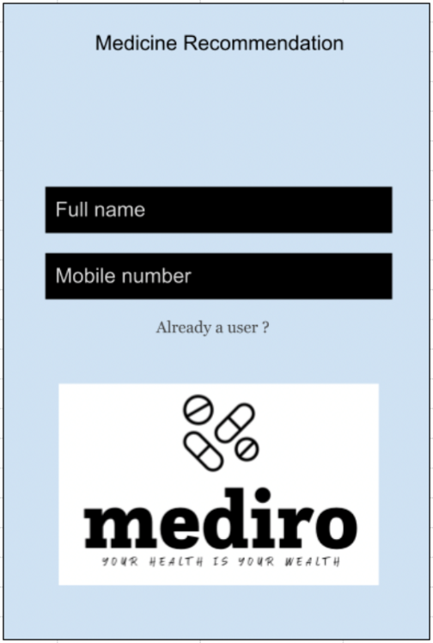 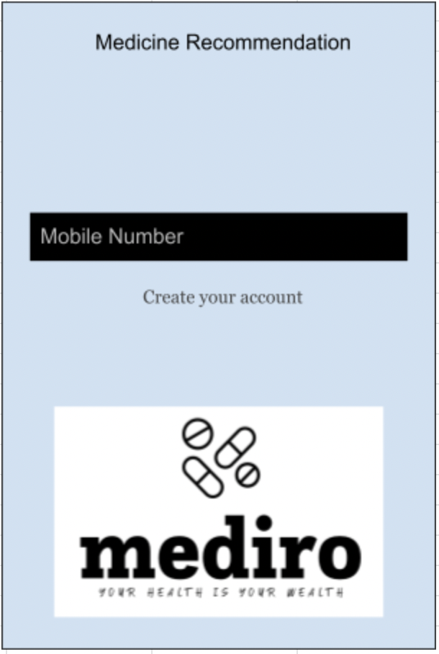 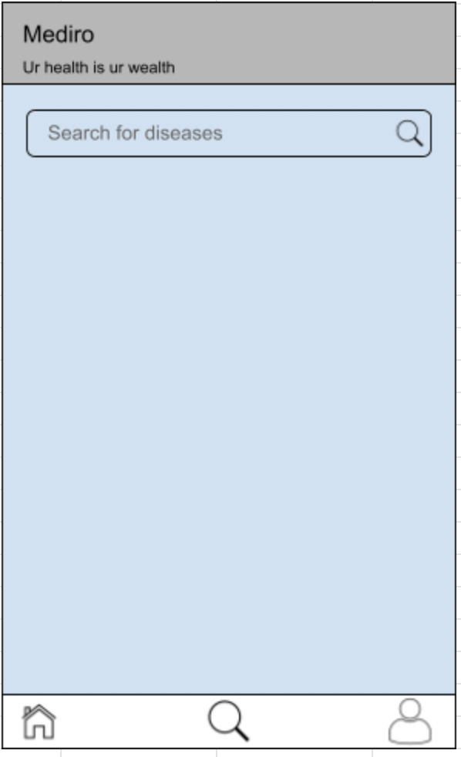 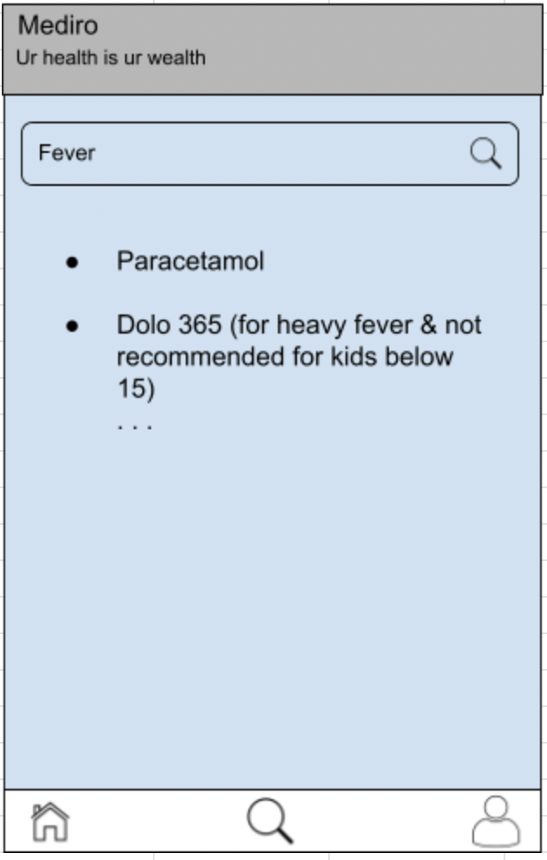

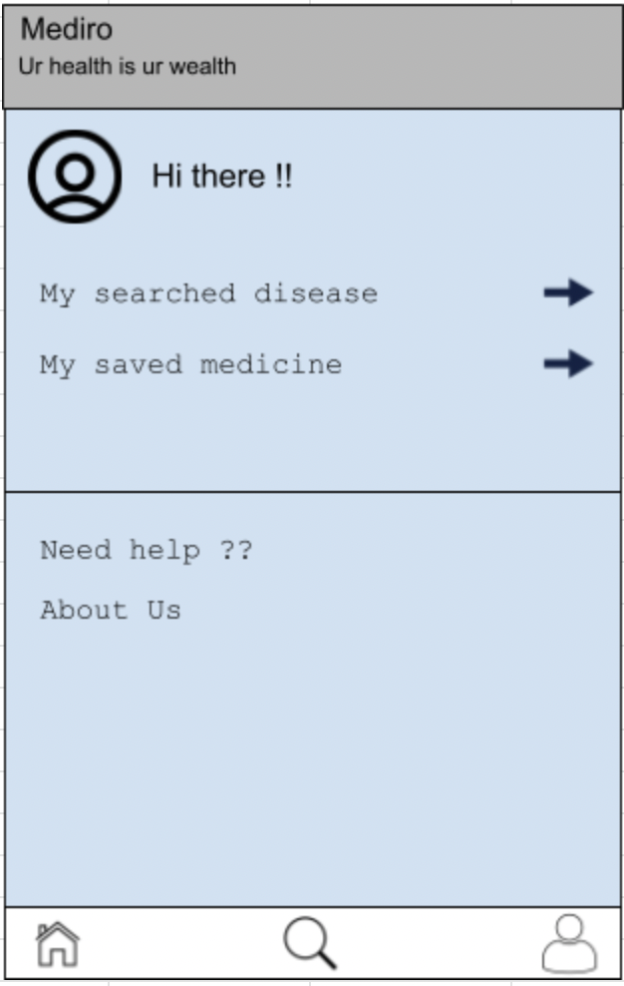

### Hardware Interface

Any Android device which is working on android-4.4 or greater.

### Software Interface

This application is build using Android Studio Framework. It can work on any android device which have an android system greater or equal to android-4.4.

### Communication Interface

The Medicine recommendation Application will be available at play store.

## Other Nonfunctional Requirements

### Performance Requirements

* + - The Proposed application that we are going to develop will be used as the chief performance system within the different Medical of the hospital which interacts with the medical staff and patient Therefore it is expected that the database would perform functionally all the requirement that are specified by the Me and My team.
    - The Performance of the Application should be fast and accurate.
    - Medicine Recommendation Application shall handle expected and non-expected errors in ways that prevent loss in information and long downtime period Thus it should have inbuilt error testing to identify invalid username/password.
    - The Application should be able to handle large amount of data Thus it should accommodate high number of medicine and user without fault.

### Safety Requirements

The Database may get crashed at any certain time due to virus or operating system failure Therefore it is required to take database backup so that the database is not lost.

### Security Requirements

* Application will use secured Database.
* Normal users can just read information but they cannot edit or modify anything expect their personal and some other information.
* Application will have different types of users and every user has access constraints.
* Proper user authentication should be provided.
* No one should be able to hack user's password.
* There should be separate accounts for admin and members such that no member can access the database and only admin has the rights to update the database**.**

### Software Quality Attributes

* + - Admin creating the project, admin will have the right to create changes to the application, But the members cannot do changes.
    - The Project should be open source.
    - The Quality of the database is maintained in such a way so that it can be very user friendly to all the users of the database.
    - The user will easily go to the Application.